COMPUTER GRAPHICS

FINAL PROJECT REPORT: CANCAN TAPTAP GAME



**COMPOSED BY:**

Jordanatha - 2001586174

1. Project Description

Can can taptap game is a game that requires you to press the button desired (c, n, m) to kill the beat provided by the game and make more score by killing more beat. This game uses Can can song by Offenbach as the song to be played in this game. There are two stages of the game, easy and hard which the hard difficulty produces more beat and beat drop’s speed than the easy difficulty. Beats will drop to the place desire to be killed and the beats are the same as the song’s beat as it has been adjusted to be the same as the song’s beat. Each beat killed gives the user 1 score for them. There is also grades to be shown at the end of the game as following:

**Easy Hard**

<50 = Fail <350 = Fail

50-100 = C 351-450 = C

101-150 = B 451-550 = B

>150 = A >550 = A

1. Contributions of Every Group Member

I am alone in making this project, so I did everything in this game from making the lanes, beats, logics behind it, main menu, and all the things related to the project.

1. Modeling Technique Used

I do not import any 3D models for this game as I only used sphere for the beats, box for the lanes, and torus for the place to kill the beats (endings).

1. Interactivity Supported

I did put some interaction between the user and the game as it requires the user to press the desired button (c, n, and m) to kill the beats when they are in the end of the line. I also did an animation when the endings (torus) is clicked, they will go up and down again in 3 frames. For the song, I used well-known song so that people know the song and want to play it along.

1. Application Manual

The application starts with the main menu like this:

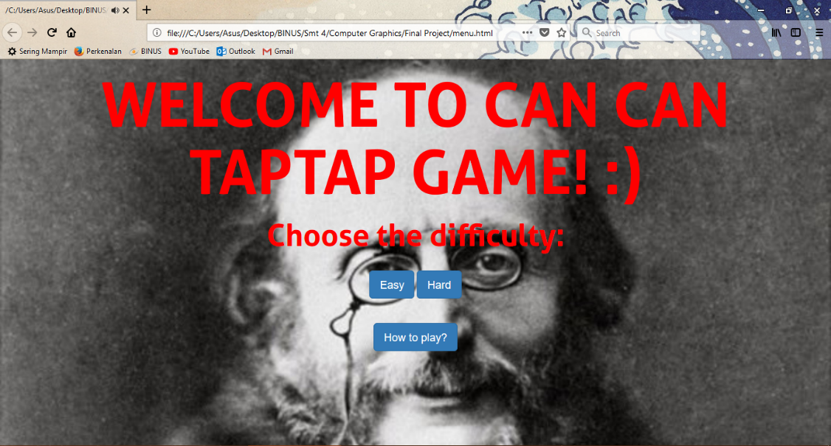

Then, user get to choose what difficulty do they want to play, it can be easy, or hard. The difference between it is the tempo of the song, the number of beats produced, and also the dropping speed of the beats. There is also “How to Play” button in it, if you click it, there will be a page helping you to play like:

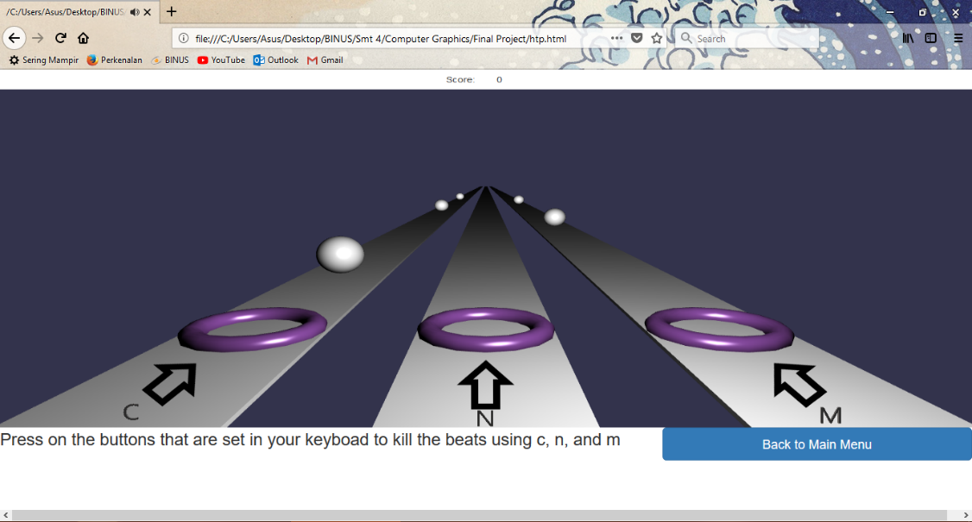

That is the how to play page that will help user to play the game, it is basically telling user to press c, n, and m when the beat is dropping close enough with the end(the circle).

When user press either hard or easy, it will show a page like:

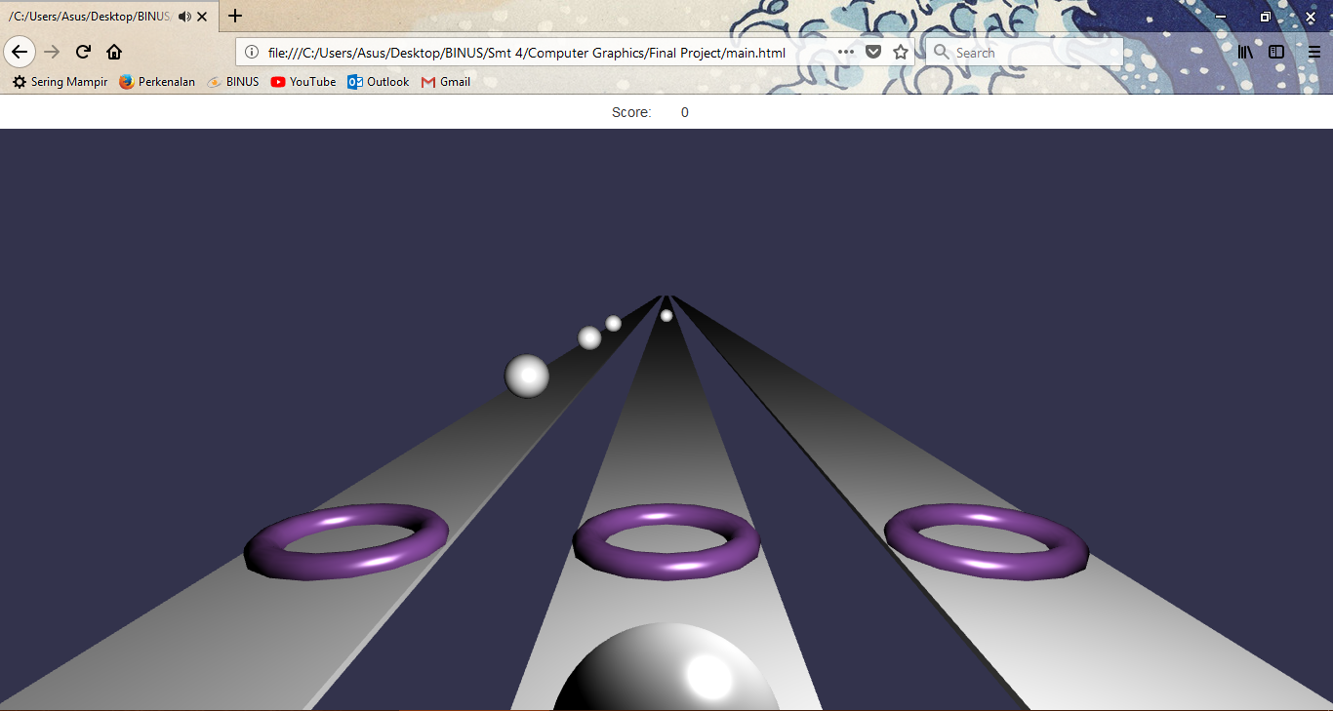

At the end of the game, there will be shown a score board like this:

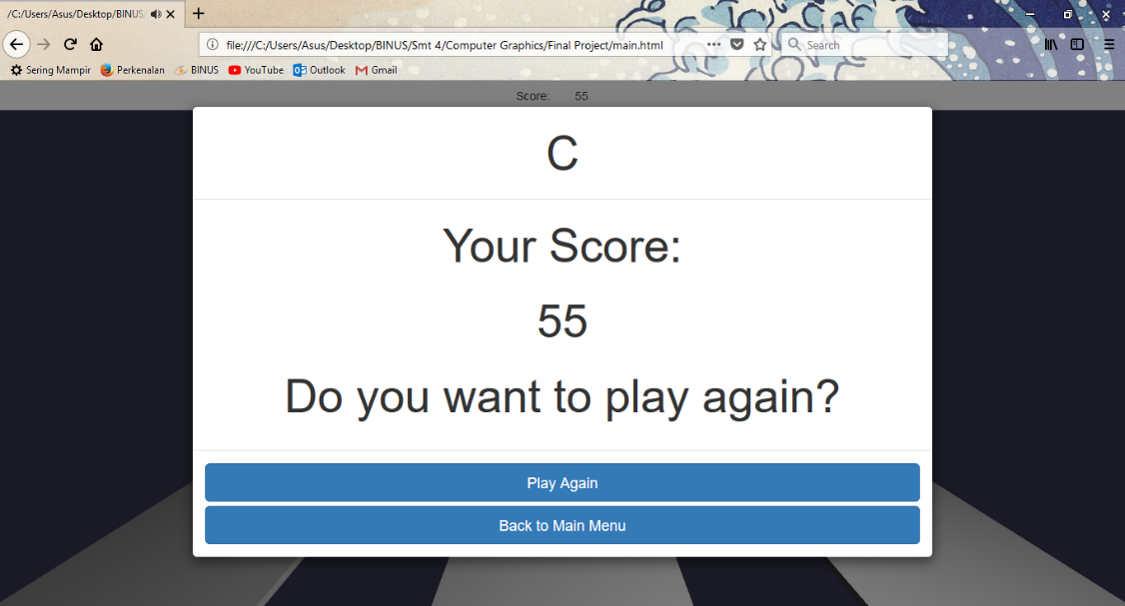

There are several parts of it, on the top there is “C”, it means grade. And there is score and 2 buttons for the user to decide whether they want to play again or back to main menu